Git Task ---------------------------Submitted by Monika Pawar -------------------------------------------

**PRACTICAL TASK**

* Initialize an empty Git repository on your local machine with the name

**“gitlocal”** and make a **README.md** file in that directory which should contain

your name as a heading and a hello

message (<https://www.makeareadme.com/>)

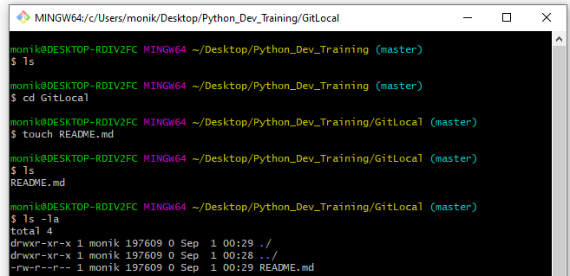

* Now check the status of your git directory and push all the files in that

directory to your GitHub repo which you have made in the first step. With a

massage “First Commit to Git Repo”.

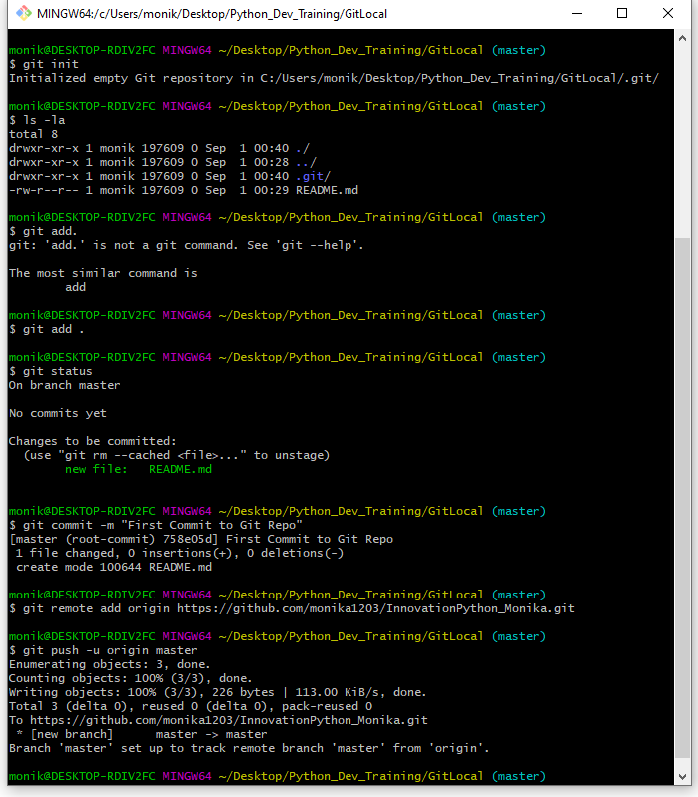

* Now add a file to your GitHub repo named “demo.txt” from the GitHub console

with content: “This is the demo file before modifications”.

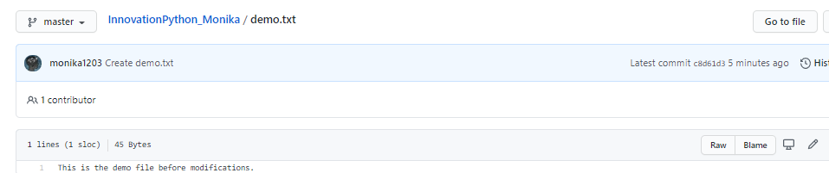

* Pull the changes in your Git repo to your local machine git directory named

**“gitlocal”** and check the status for the modifications done in that repo. This

time demo should be visible in your local machine.

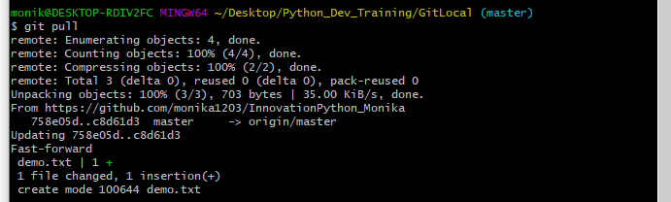

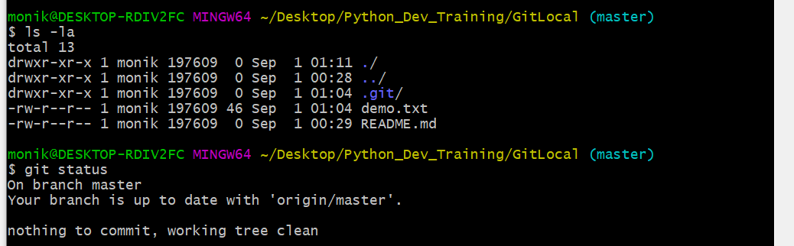

* Now make a new branch in your local machine with the name “**developer”**.

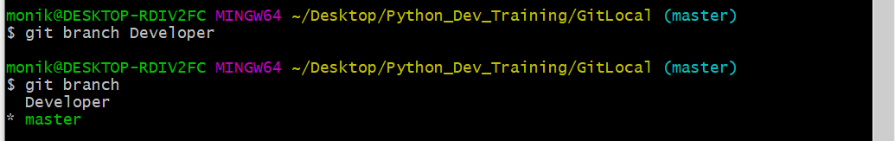

* Edit that demo file and write some content in that eg: “This is a demo file after

modification” and push the modifications to your GitHub repo from the

**developer** branch with a commit message “Commit from developer branch”.

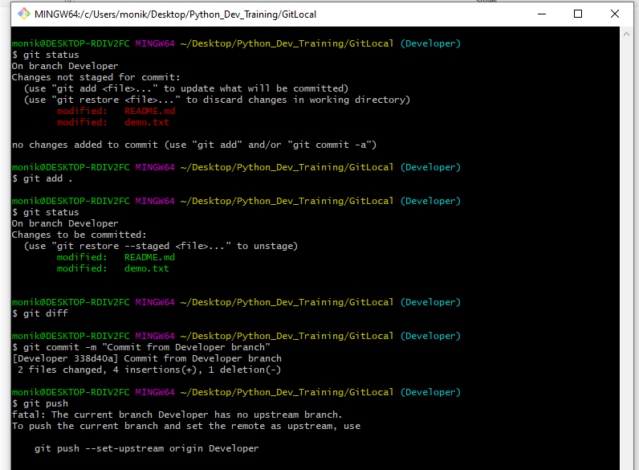

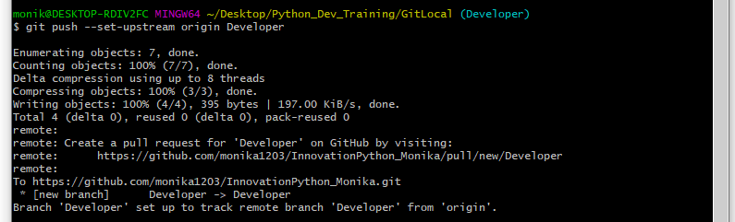

* Go to the GitHub console and generate a merge request to master branch

after checking the modifications.

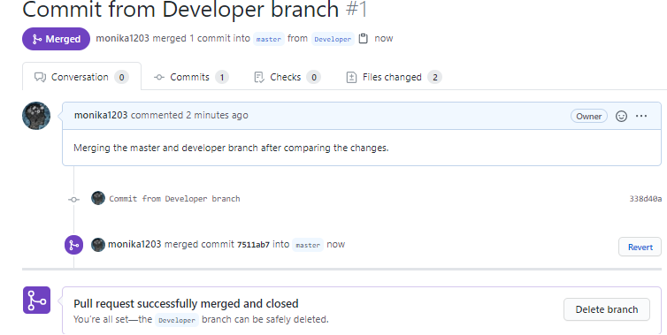

* After merging you could see the modified content in the demo file.

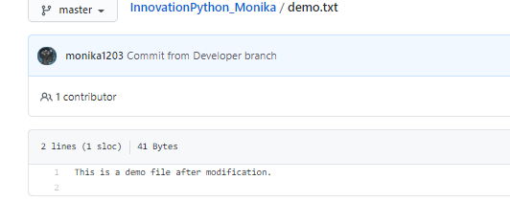

* Now revert back to the previous version from terminal. After switching back to the previous version your demo file should have the content: This is a demo file before modification.

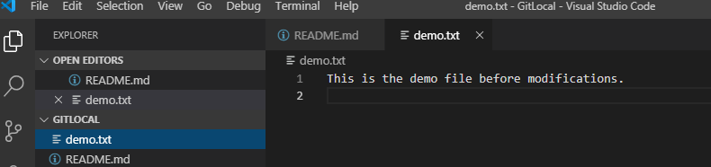

● At the end delete the developer branch.

